
08
Fall

CONFIDENTIAL
The information contained within this document is confidential and should may not be retransmitted or duplicated in whole, or in part, nor may any of the information contained therein be disclosed without the prior consent of the directors of MediaBrix Inc. (‘the Company’). A recipient may not distribute, directly or indirectly (whether through an agent or otherwise) any text, concepts or ideas contained herein to another institution or person without the prior approval of the directors of the Company. Failure to maintain confidentiality may result in the termination of any working relationship and/or potential legal action.

Dynamic Creative Templates
Product Requirements
This document contains the high-level business requirements for the requested feature. The purpose of this document is to collect and prioritize requirements for the purpose of stakeholder approval and development effort estimations.
Version
0.2

Overview
In an effort to start componentizing the creative templates so only the fields for the necessary functionality appears, a framework will be created that allows for the creation of functional components that drive the fields in a template. This will also be the foundational framework for componentizing the code so it can be used by multiple templates. In the future, an update to one component will apply across multiple templates and creatives.
The core of the new framework is the component. Components consist of functionality that can be added to a template. For example, Pinterest Pin would be a component consisting of the image URL, Pin messaging and the Pinterest Pin icon. Components use either standard fields (ie, URL field, Text field, Date Picker) or MB fields. MB fields are those specialized fields specific to the Platform. For example, VAST video field would allow the user to choose from a list of existing VAST IDs or to add a new VAST video. This specialized field would be integrated into our existing VAST management.
Components can be assigned to a group so it can be displayed on the template in an organized fashion. For example, the Pinterest Pin would be in the Social Buttons group so it displays along with other social functionality in the template.
When creating a component, the user adds fields and then defines each field.

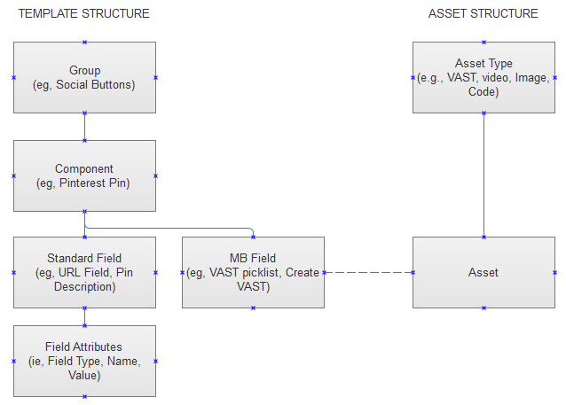

Overall Use Case
Step | Player | Use Case
 | User | Create Components and assign them to groups
 | User | Create a template and select components
 | User | Create creatives from templates

Use Cases

Use Case: Creating a Template
Step | Player | Use Case
 | User | Go to the Template section under Administration link in the main menu
 | User | Click on “Templates”
 | System | Display the list of templates
 | User | Click “Add Template”
 | System | Display the Template Creation Page
 | User | Enter the Template Name, Platform and Description
 | System | After the user selects the Platform, the system will display a list of available components for the template
 | User | Select existing components, or add a new component to the template
 | User | Define if component is required and/or pre-selected
 | User | Adds the HTML code to the template
 | User | Click Save

Template Build Page (CONCEPT SCREEN. NOT FINAL)
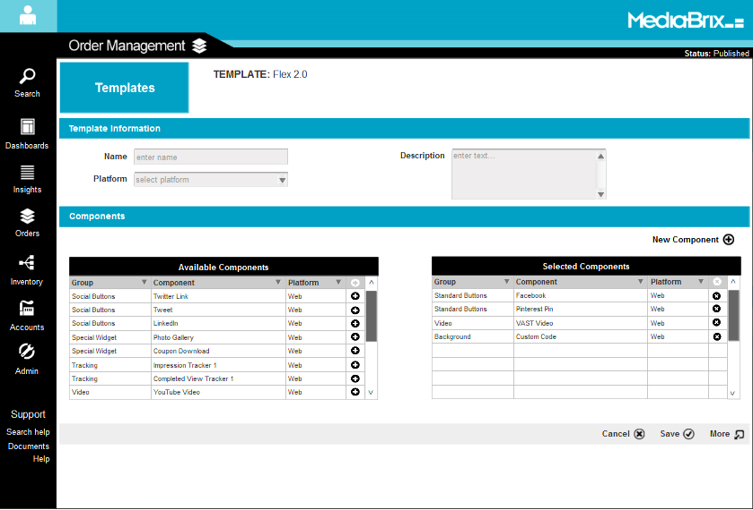

Use Case: Creating a Component
Step | Player | Use Case
 | User | Go to the Template section under Administration link in the main menu
 | User | Path 1: Click on “Components”  Path 2: When in the Template Creation/Edit page, click “Add Component”
 | System | Path 1: Display the list of components
 | User | Path 1: Click on “Add Component”
 | System | Display the Component Creation Page
 | User | Enter the Component Name, assign it to a group or add a new group
 | User | Add fields
 | User | Click Save

Component Build Page (CONCEPT SCREEN. NOT FINAL)
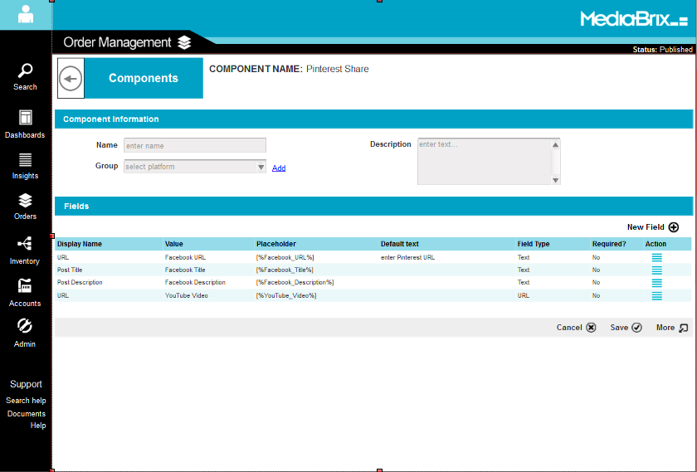

Use Case: Creating a Field (CONCEPT SCREEN. NOT FINAL)
Step | Player | Use Case
 | User | Create a component
 | User | Click on “Add Field”
 | System | Display the field creation page
 | User | Enter the unique field name, display name to appear in the templates, placeholder name that to appear in the code, the field type and if the field is required
 | System | Once the user chooses the field type, the system will display the fields other attributes. For example, a field type=list will display a form to enter all the options available in the list.
 | User | Click Save

Field Builder Page (CONCEPT SCREEN. NOT FINAL)
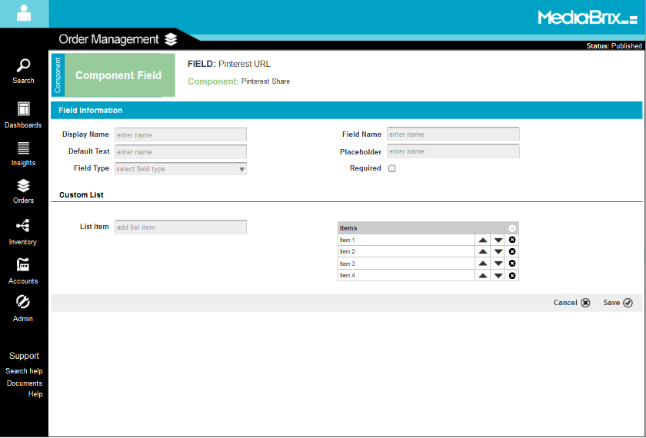

Use Case: Creating a Creative
Step | Player | Use Case
 | User | Under the Flight, click on “Add Creative” (current functionality)
 | User | Select the Ad Type and one of the associated creative templates (current functionality)
 | User | Click Start (current Functionality)
 | System | Display the Dynamic Creative Template page
 | User | Enter the Creative Name
 | User | Choose the available components.  Note: That there are some preselected components
 | System | Display the component and its fields
 | User | Fill in the required fields for each component
 | User | OPTIONAL: Customizes the code by clicking on Custom Code
 | User | Click Save
 | System | Fills in the user’s values in the placeholder names of the code and submits the creative to DFP

Creative Template (CONCEPT SCREEN. NOT FINAL)
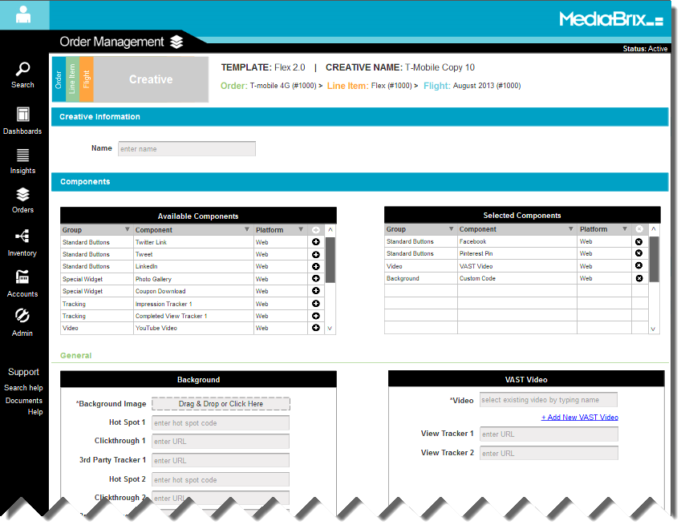

General Product Requirements
# | Requirement

New Pages
- Template List
  - Template Builder Page
- Component List
  - Component Builder Page
- Group List
  - Group Editor overlay
- Field Builder Page

The following fields will be available when building a component:

Custom Fields:
- Single Select List
- Text Field
- URL Field
- Text Area Field
- Multi-Select List

MediaBrix Specific Fields:
- Image Upload Field
- Video Upload Field
- VAST Video Field
- Date Selector Field

Single Select List Field & Multi-Select Field
Gives the user the ability to add and manage items in the list

Image Upload Field Details
Widget that allows the user to select a local image and save it to our CDN.

VAST Video Field Details
A single select field that allows the user to choose from a list of existing VAST videos. Also provides a link to create a new VAST video directly from the template

Video Upload Field Details
Widget that allows the user to select a local video and save it to our CDN

Review & Sign Off

Effort Assessment

- Original Estimated Hours: ##
- Revised Estimated Hours*: ##
* Subject to change upon review of final specification

Sign Off

The following stakeholders have reviewed this document and find that it meets the company’s requirements.

Sponsor | Name | Date
Executive | XXXXXX
PM | XXXXXX
Stakeholder | XXXXXX

